LAB Manual

PART A

(PART A : TO BE REFFERED BY STUDENTS)

**Experiment No.02**

**A.1 Aim:**

**To write a program using python to compute different distances within an image and two images.**

**A.2 Prerequisite:**

1. Understanding of fundamental programming functions/commands and environment of Python (Refer the OpenCV documentation),

2. Availability of Soft copy of your Photograph for experiment.

3. Understanding of correlation among pixel intensities and concept of distance calculation.

**A.3 Outcome:**

**After successful completion of this experiment students will be able to**

1. Explore and understand the importance of Correlation among neighborhood pixel intensities.
2. Understand various distance measuring equations.
3. Write program to differentiate between two images based on following intensity distance calculation methods:
4. Euclidian Distance
5. City block distance
6. Chess board distance

**A.4 Theory:**

**A.4.1 Relationship among pixels:**

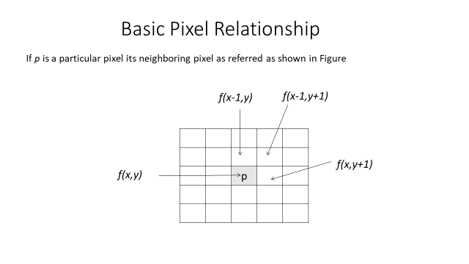

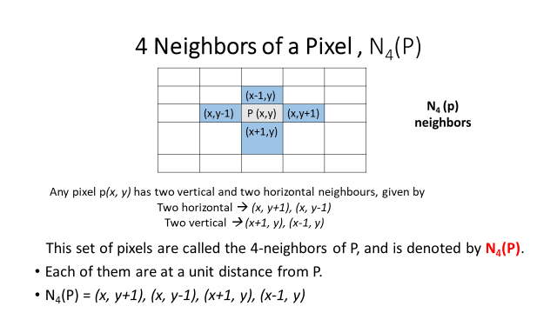

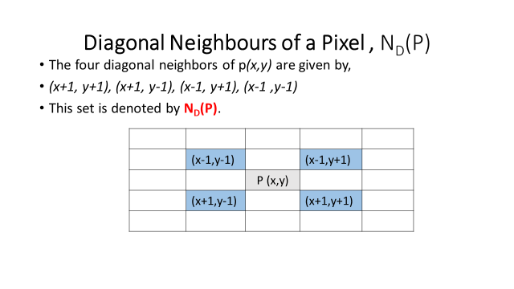

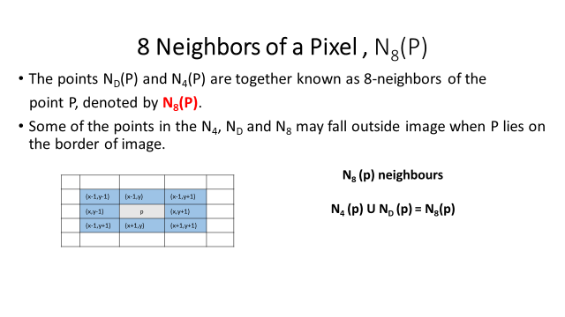

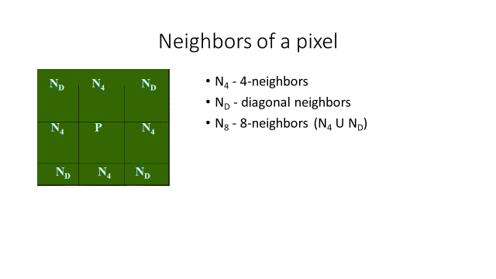

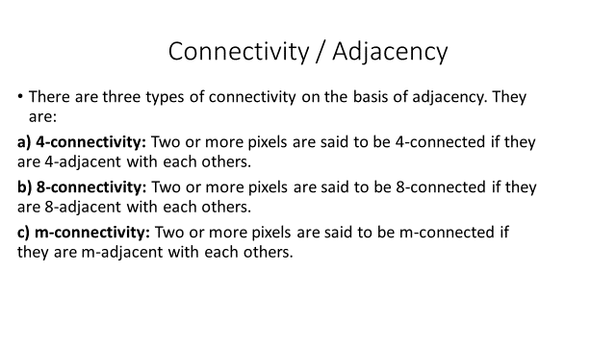

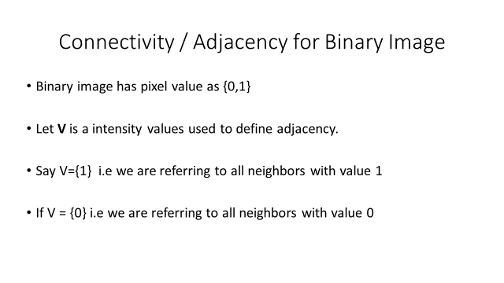

Each pixel in the digital image has correlation with its neighboring pixel with respect to the intensity values they carry. This relationship focuses on the connectivity of the pixel with another pixel in the image. The connectivity among pixels can be determined in 3 ways: 4 connectivity, 8 connectivity and m connectivity. Lesser the difference among the pixel intensities w.r.t. to the neighboring pixel can provide better quality of the image as a whole and this can be said to have the strong correlation among them.

There are various distance measuring methods (given in section A.4.2 below) which can be utilized to check the correlation among pixels. The distances calculated by these methods can be used to decide the level of correlation among pixels. Lesser the distance calculated that mean there is better correlation exists among the pixels and vice versa.

**A.4.2. Various distance measures:**

1. **Minkowaski Distance:**

The general formulae of Minkowaski distance is given below:

${\left(\sum_{i=1}^{n}{{\left|xi-yi\right|}^{p}}\right)}^{1/p}$…..Equation (1)

1. **Euclidian Distance:**

The Euclidian Distance formula can be obtained if the value of p =2 taken in the Minkowaski equation given in the equation (1).

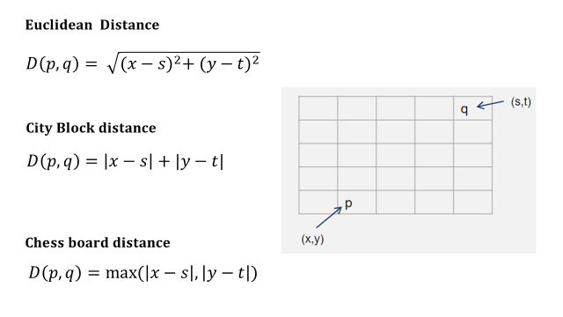

**A.5 Procedure/Algorithm:**

**A.5.1 TASK 1:**

1. Create a new python file.

2. Write a program to Read an Image and display the same after converting it to gray scale.

3. Modify the intensity values of at least 10 pixels in input images randomly at random positions.

4. Find the adjacent pixels for these modified pixels w.r.t. 4 and 8 connectivity in the block of 3x3, and comment on closeness of pixel with its neighbors.

6. Observe the output and complete PART B of lab manual.

7. Save and close the file and name it as **EXP2_Task1_your Roll no.py**

**TASK 2:**

1. Create a new python file.
2. Read two input images and display the same after converting it to gray scale.
3. Show the menu and ask for user choice of distance measure to be used.
4. Ask for comparison whether to be done between same images or two difference images
5. Compare both images pixel by pixel using distance measuring method chosen.
6. Comment on the time taken by the program to complete the task and comment whether both input images are same or different.
7. Complete PART B of lab manual.
8. Save and close the file and name it as **EXP2_Task2_your Roll no.py**

**********************

PART B

(PART B : TO BE COMPLETED BY STUDENTS)

***(Students must submit the soft copy as per following segments within two hours of the practical. The soft copy must be uploaded on the Blackboard or emailed to the concerned lab in charge faculties at the end of the practical in case there is no Black board access available)***

|  |  |
| --- | --- |
| Roll No. | Name: |
| Class : | Batch : |
| Date of Experiment: | Date of Submission |
| Grade : |  |

**B.1 Software Code written by student:**

***(Paste your Matlab code completed during the 2 hours of practical in the lab here)***

**B.2 Input and Output:**

***(Paste your program input and output in following format, If there is error then paste the specific error in the output part. In case of error with due permission of the faculty extension can be given to submit the error free code with output in due course of time. Students will be graded accordingly.)***

**B.2.1 TASK 1**

**Input Images:** Your photograph

**Output:**

1. Image with the visible random intensity changes.
2. Distance of each modified pixels in its 3x3 block w.r.t. 4 and 8 connectivity.
3. Percentage of difference w.r.t. the neighbor
4. Comment on closeness of modified pixel with its neighbor.

**B.2.2 TASK 2**

**Input Images:** Your photograph and output of TASK 1

**Output:**

1. Menu choices.
2. Menu selection
3. Output for each choices w.r.t. to comparison of same image and two different images
4. Time taken to compare images for all distance measures.

**B.3 Observations and learning:**

***(Students are expected to comment on the output obtained with clear observations and learning for each task/ sub part assigned)***

**B.4 Conclusion:**

*(****Students must write the conclusion as per the attainment of individual outcome listed above and learning/observation noted in section B.3)***

**B.5 Question of Curiosity**

***(To be answered by student based on the practical performed and learning/observations)***

Q1: List out possible real life problems which can be solved using image processing and distance measures.

Q2: If you are provided with 10 images of two difference classes (i.e. type of images: for example class1: animal images, class 2: human face images) (5 images in each) then can you comment on difference between inter class and intra class correlation.

************************